MAINTENANCE IS….  Parts, labor and travel expenses for work performed  on a preventive basis to inspect and maintain operation of a backup power system.  FIRST STOP  • Change Oil/Filter  • Change Air Filter – If needed  • Change Spark Plugs  • Check Spark Plug Wires  • Check Electrical Connections  • Check Battery Load Capacity  • Check Battery Charger Output  • Clean Unit  • Check Volts and Engine Speed  • Check for Fluid Leaks  • Apply Software Updates  • Adjust Valves - If needed  SECOND STOP  • Check Oil/Filter – change if needed  • Check Air Filter – change if needed  • Check Spark Plugs – change if needed  • Check Spark Plug Wires  • Check Electrical Connections  • Check Battery Load Capacity  • Check Battery Charger Output  • Clean Unit  • Check Volts and Engine speed  • Check for Fluid Leaks  • Check Battery Voltage  • Adjust Valves - If needed  IMPORTANT SCHEDULING INFORMATION  Advanced Energy Systems will complete your Spring/Summer stop between March and August and your Fall/Winter stop between September and February (weather permitting). Maintenance stop dates are determined by Advanced Energy Systems and there is no need for you to be home. | Emergency Calls  An Emergency Call response is applied to service calls defined as an “Emergency” by the customer whom is requesting emergency service outside the regular maintenance schedule.  Common Troubleshooting Tip:  Should your generator fail to operate when your power is out, try resetting the unit’s ON/OFF/AUTO Switch.  We Accept:        Register On-line Today!  www.AdvancedEnergySystems.info  Advanced Energy/Brumm Enterprise  7/  Scan to register for Maintenance Program    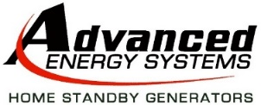  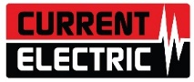  www.AdvancedEnergySystems.info  2418 Highview Street, Suite A • Spring Grove, IL 60081  Office: (815) 675-1555 Fax: (815) 675-1558  Contact: Maintenance Coordinator  Email: Maintenance@AdvEnergy.net  A subsidiary of    7/2025 |  |  | 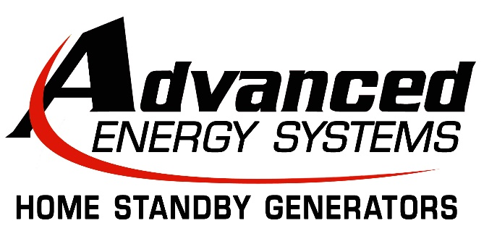  Preventive Maintenance Program Options for your    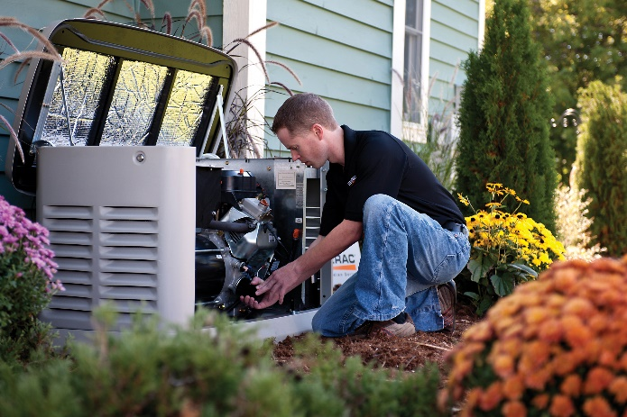    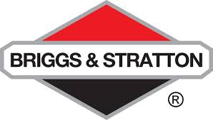  Home Standby Generator  All generators require periodic maintenance to ensure maximum performance for years of reliable service. These Maintenance Programs are designed for a worry-free ownership experience.  Register On-line Today!  www.AdvancedEnergySystems.info
  We are committed to improving the quality of life for our customers by providing the highest possible quality of environmental equipment for their homes and families. We are dedicated to creating a lifetime relationship with our customers by instilling in all of our employees the desire to serve with a sincere and caring attitude that far exceeds our customer’s expectations.  ACCESSORIES AVAILABLE  Sold separately and added to the cost of maintenance  Air Cooled Battery Block Warmer  Liquid Cooled Battery Battery Warmer  Generac Mobile Link Precast Concrete Pads  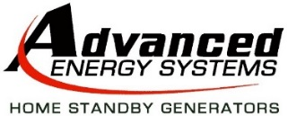  2418 Highview Street, Suite A • Spring Grove, IL 60081  Office: (815) 675-1555 Fax: (815) 675-1558 |  | 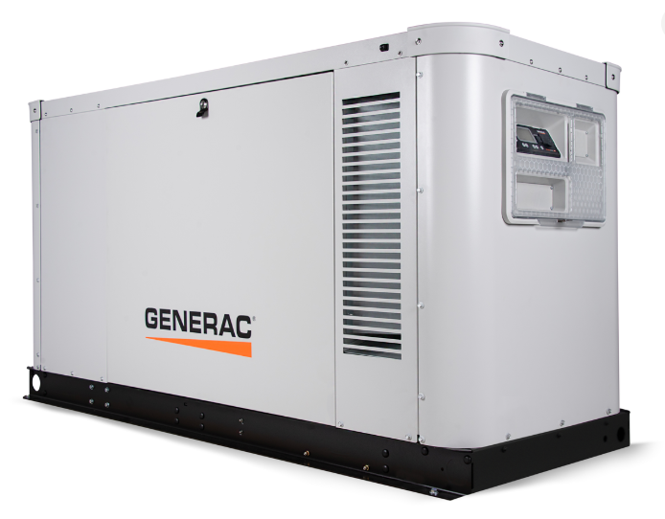  GOLD  Air Cooled ….….. $524.00  *Liquid Cooled... $675.00  Two Maintenance Stops per Year  • All labor and travel charges included.  • All standard maintenance parts included.  • 1 Service call and trip charge included.  • Priority Emergency Response.  • 5% Discount on service parts.  SILVER  1 Year 2 Years 3 Years  Air Cooled ……... $350.00 $655.00 $949.00  *Liquid Cooled.... $500.00 $950.00 $1,400.00  Two Maintenance Stops per Year  • All labor and travel charges included.  • All standard maintenance parts included.  • Priority Emergency Response.  • 5% Discount on service parts.  *Special pricing may apply  *Special pricing may apply *Special pricing may apply  Rates subject to change without notice. | BRONZE  1 Year 2 Years 3 Years  Air Cooled ……... $225.00 $430.00 $630.00  *Liquid Cooled.... $325.00 $600.00 $875.00  One Maintenance Stop per Year  • All labor and travel charges included.  • All standard maintenance parts included.  • Priority Emergency Response.  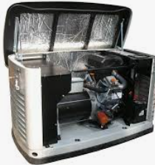  Rates subject to change without notice.  On Air Cooled Generators Only  Special pricing offers for optional items (NOT INCLUDED IN PACKAGES) Pricing is honored ONLY during a routine Maintenance stop.  Block Warmer $145.00  Battery Warmer $145.00  Block & Battery Warmer Kit $250.00  Battery (Generac Generators) $135.00  Battery (GE/Briggs Generators) $165.00  